HEALTH AI

Project documentation

1.Introduction

* Project Title: Health AI: Intelligent Healthcare Assistant
* Team leader: Kalaivani.K
* Team member: Jayalashmi.M
* Team member: Sakthi.K
* Team member: Nandhini.D
* Team member: Keerthana.M

2.Project Overview

* Purpose:

The purpose of the Health AI project is to leverage artificial intelligence to improve healthcare outcomes by enabling faster diagnosis, personalized treatment, predictive analytics, and efficient patient care management. The system is designed to support medical professionals with decision-making tools, automate routine tasks, and provide patients with accessible, data-driven health insights.

* Features:

Health AI systems offer a range of powerful features designed to enhance medical decision-making, improve patient outcomes, and streamline clinical workflows. One of the core features is **predictive analytics**, where AI models analyze patient data to forecast disease risks, complications, or treatment outcomes. **Medical imaging analysis** is another key capability, using deep learning to detect anomalies in X-rays, MRIs, and CT scans with high accuracy. **Natural Language Processing (NLP)** enables the system to extract meaningful insights from unstructured clinical notes, discharge summaries, and lab reports. Health AI also supports **real-time monitoring** by integrating with wearable devices to track vital signs and trigger alerts for abnormal readings. **Personalized treatment recommendations** are generated based on patient history, genetics, and clinical guidelines, helping doctors make informed choices. Additionally, features like **automated data entry**, **clinical decision support**, and **chatbot-based symptom checkers** contribute to greater efficiency and accessibility. All these features are supported by secure data handling, role-based access control, and compliance with healthcare regulations, ensuring that the technology is both powerful and responsible.

3.Architecture

The architecture of a Health AI system is designed as a layered framework that ensures efficient data flow, accurate model performance, and secure interaction with users and healthcare systems. At its foundation lies the **data layer**, which collects and stores structured and unstructured data from various sources such as electronic health records (EHRs), medical imaging devices, wearable sensors, and lab reports. This is followed by the **data preprocessing layer**, where data is cleaned, normalized, and transformed to be suitable for analysis. The **AI and machine learning layer** sits at the core of the architecture, where models are trained, validated, and deployed to perform tasks like disease prediction, medical image classification, and natural language understanding. A **service/API layer** exposes these AI capabilities through secure endpoints, allowing integration with external applications or hospital systems. On top of this, the **application layer** includes user interfaces like clinician dashboards, patient portals, and mobile apps that deliver insights in an accessible format. To ensure reliability, the architecture also includes a **security and compliance layer** for encryption, user authentication, and regulatory adherence (such as HIPAA or GDPR). Finally, a **monitoring and feedback loop** supports continuous model improvement based on real-world performance and user input. This modular and scalable architecture enables Health AI systems to be both flexible and robust in clinical environments.

4.Setup Instructions

Setting up a Health AI system involves a series of well-defined steps to ensure that all components—from data handling to AI deployment—are configured correctly and securely. The process begins with preparing the development environment by installing essential tools such as Python, necessary libraries (like TensorFlow, PyTorch, Scikit-learn), and setting up a virtual environment to manage dependencies. Next, the system requires the configuration of data pipelines to ingest and preprocess healthcare data, including structured electronic health records (EHRs) and unstructured data like medical images or clinical notes. Once the data is ready, the AI models can be trained or loaded if pre-trained models are already available. The system's core functionality is exposed through an API, typically built using frameworks like FastAPI or Flask, which allows other applications or users to interact with the AI services. If a user interface is included, it must also be initialized—either as a web-based dashboard or a simple frontend application using tools like React or Streamlit. For production environments, Docker is often used to containerize the application, enabling consistent deployment across systems. Environment variables, security configurations, and API keys should also be set using .env files or configuration management tools. After deployment, it's crucial to test the API endpoints, verify model responses, and monitor system performance. This setup ensures the Health AI application is ready for real-world usage with reliable, secure, and efficient operation.

5.Folder Structure

* **Data/**

Contains all healthcare-related data files

raw/ (unprocessed data)

processed/ (cleaned and formatted data)

external/ (third-party datasets)

* **notebooks/**

Jupyter notebooks for data exploration, prototyping, and experiments

* **src/**

Core source code

data_preprocessing/ (scripts for data cleaning and transformation)

models/ (model training and evaluation scripts)

prediction/ (model inference and prediction code)

nlp/ (natural language processing modules)

utils/ (helper functions and utilities)

* **api/**

Backend API code

main.py (API entry point)

routes/ (API route handlers)

models/ (request/response schemas)

* **models/**

Saved and serialized trained AI models

* **tests/**

Unit and integration test cases for code and API

* **configs/**

Configuration files (e.g., YAML or JSON) for environment and model settings

* **logs/**

Logs for application runtime, training, and errors

* **Dockerfile**

Docker container build instructions

* **requirements.txt**

List of Python dependencies

* **README.md**

Project overview and setup instructions

* **.env**

Environment variables such as API keys and database credentials

6.Running the Application

To run the Health AI application, first ensure you have all the necessary dependencies installed, preferably within a Python virtual environment to avoid conflicts. Begin by preprocessing your healthcare data using the provided data processing scripts, which clean and normalize raw medical records, images, or wearable data. If you don't have a pretrained model yet, train your AI model using the training scripts, then save the model for inference. Next, start the backend API server—commonly built with FastAPI or Flask—by running the main application script, which exposes endpoints for predictions and other AI services. If your system includes a frontend dashboard, launch it separately, for example, with React’s development server or Streamlit, to provide users with an interactive interface to upload data and view AI-driven insights. Alternatively, you can run the entire application within Docker containers for easier deployment and scalability. Once running, test the API using tools like Swagger UI or curl to ensure the AI predictions are functioning as expected. Throughout, monitor logs and performance metrics to debug any issues and maintain the system’s reliability. This sequence allows the Health AI solution to operate end-to-end, supporting healthcare providers and patients with intelligent data-driven insights.

7.API Documentation

The API documentation for a Health AI system provides a detailed overview of the available endpoints that enable users to interact with the AI services. Typically, it describes how to send requests and receive responses for key functionalities such as submitting patient data, medical images, or clinical notes for analysis, and retrieving AI-driven predictions or recommendations. The documentation outlines the required input formats, including JSON schemas or multipart forms, authentication methods like API keys or OAuth tokens to ensure data security and compliance, and the structure of response payloads that may include risk scores, diagnostic labels, or confidence intervals. It also covers error handling, specifying common HTTP status codes and messages to guide developers in troubleshooting. Often integrated with interactive tools like Swagger or OpenAPI, the documentation allows users to explore and test endpoints directly. Overall, this comprehensive guide ensures that healthcare providers, developers, and integrators can seamlessly incorporate the Health AI capabilities into their workflows or applications while maintaining regulatory standards and data privacy.

8.Authentication

Authentication in a Health AI system is a vital security measure that ensures only authorized users can access sensitive medical data and AI services. Typically, the system implements robust methods such as API keys, OAuth 2.0, or JSON Web Tokens (JWT) to verify user identities securely. When users—whether healthcare professionals, patients, or administrators—log in or connect to the system, they receive unique tokens or credentials that must accompany each request to protected endpoints. This process helps prevent unauthorized access and protects patient privacy in compliance with healthcare regulations like HIPAA and GDPR. Additionally, authentication mechanisms often include role-based access control (RBAC) to restrict functionalities and data visibility according to the user's role, ensuring that users only access information relevant to their responsibilities. Secure transmission protocols such as HTTPS further protect authentication data during communication. Overall, effective authentication is foundational to maintaining trust, data integrity, and regulatory compliance in Health AI applications.

9.User Interface

The user interface (UI) of a Health AI system is designed to provide an intuitive, accessible, and secure experience for various users, including healthcare professionals, patients, and administrators. It typically features a clean and responsive dashboard that allows clinicians to input patient data, upload medical images or lab results, and receive AI-generated insights in real-time. The interface may also include visualizations such as risk scores, charts, or annotated medical images to help users interpret predictions more effectively. For patients, the UI might offer simplified views of their health status, alerts, and personalized recommendations, while maintaining strict privacy controls. Role-based access ensures that each user only sees the data and tools relevant to their responsibilities. Additionally, the interface often integrates seamlessly with existing hospital systems or electronic health records (EHRs) to support clinical workflows. Overall, the UI of a Health AI system plays a critical role in ensuring that complex AI outputs are understandable, actionable, and embedded naturally into healthcare environments.

10.Testing

Testing in a Health AI system is a crucial process that ensures the reliability, accuracy, safety, and compliance of the application before it is deployed in real-world clinical environments. It involves multiple layers of testing, starting with **unit tests** to validate individual functions such as data preprocessing, prediction logic, and API responses. **Integration testing** ensures that different components—like the AI model, database, and user interface—work together as expected. **Model validation and performance testing** are essential to evaluate the AI’s diagnostic accuracy using metrics like precision, recall, F1-score, and ROC-AUC, often on separate validation and test datasets. In the healthcare domain, **bias and fairness testing** is also critical to ensure the model performs equitably across different demographic groups. **Security testing** checks for vulnerabilities in data handling, authentication, and access control. Additionally, **compliance testing** ensures that the system adheres to regulations like HIPAA or GDPR. User acceptance testing (UAT) with clinicians and healthcare staff is often conducted to confirm the system’s usability and clinical relevance. Altogether, this rigorous testing framework helps build trust in the Health AI system and ensures it delivers safe, accurate, and ethical outcomes in medical practice.

OUTPUT

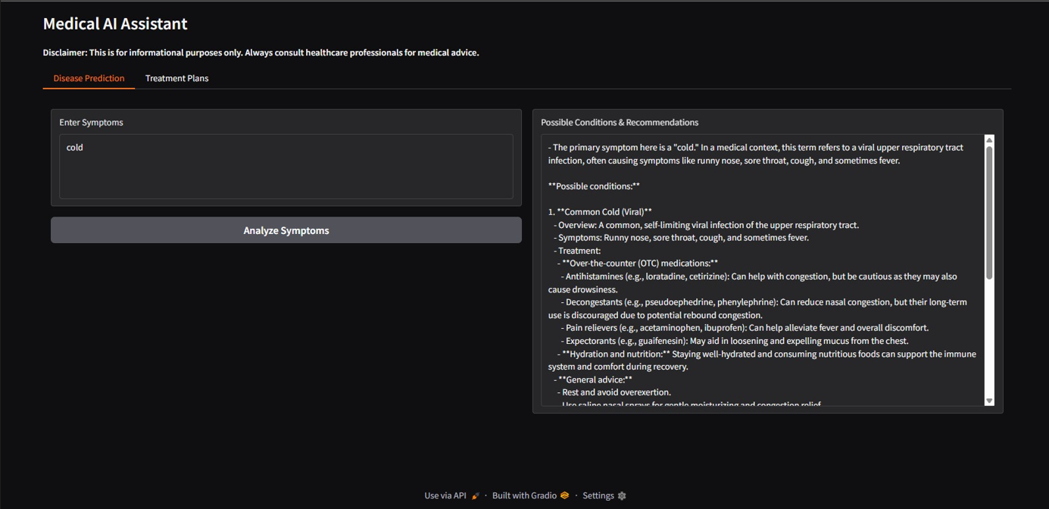

* **Conclusion**

In conclusion, the Health AI project represents a significant step toward transforming healthcare delivery through the power of artificial intelligence. By integrating advanced data processing, predictive modeling, and intuitive interfaces, the system offers clinicians and patients intelligent tools for early diagnosis, risk assessment, and personalized treatment planning. Throughout the development lifecycle, emphasis was placed on data privacy, compliance, and user-centric design to ensure the solution is both ethically sound and practically effective. Rigorous testing and secure deployment practices further ensure that the system performs reliably in real-world clinical settings. As healthcare continues to embrace digital innovation, this Health AI project lays a strong foundation for scalable, transparent, and impactful AI applications that can enhance patient outcomes, reduce workloads for medical professionals, and support data-driven decision-making across the healthcare ecosystem.

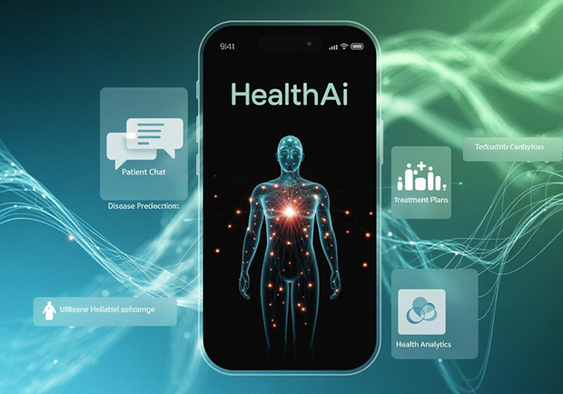

***THANK YOU***